HCA Healthcare India

Cardington Application Overview

Operating Procedure (SOP) Version 1.0

19-06-2026


Contents
Version Control: 2
1. Purpose and Objective 3
2. Application / Product Overview 3
2.2 Business Process: 3
2.3 Functional Details: 3
3. Technical Overview 4
3.1 Application Architecture: 4
3.2 Infrastructure: 5
3.3 Service Management: 6
3.4 CI/CD & Deployment: 6
3.5 Logging & Diagnostics: 8
4. Performance, Security & Scalability: 8
5. Source Code Walkthrough: 9
6. Operations and Maintenance: 9
7. SRE Operational Activities (Daily / Weekly / Monthly) 10
8. Key POCs 12

Version Control:

Version Number (V1.0, etc.) | DRAFT DATE | APPROVAL DATE | CHANGE DESCRIPTION | DOCUMENT PREPARER (HCA GCN) | DOCUMENT OWNER (HCA US)
1.0 | 19-06-2026 |  | Initial draft | Pavan Kalyan

1. Purpose and Objective
The purpose of this SOP is to establish standardized operational and support procedures for the Cardington application, ensuring consistent availability, accurate data synchronization, and reliable support for HR data flowing between the GHR portal and the Lawson ERP (S3) system.

2. Application / Product Overview
- Cardington is a Java Spring Boot REST API that acts as a wrapper for Lawson DME services, allowing other HCA applications to access Lawson data in a RESTful manner.
- It functions as a read-only intermediary (IPA Middleware – Infor Process Automation) between the Infor GHR (Landmark) portal and the legacy Lawson ERP (S3) system.
- Cardington has no user interface; it is accessed purely via API calls (e.g. through Postman, curl, or calling applications), which limits monitoring to server and port health rather than UI-based synthetic checks.
- The application is hosted on shared on-base proxy servers alongside other ERP services such as OnbaseProxy and Trinisys.

2.2 Business Process:
Personnel and HR events (hires, transfers, promotions, name changes, benefit elections, etc.) are created or updated in Infor GHR (Landmark). Cardington listens for these changes, validates them against Lawson using read-only DME queries, and synchronizes the data down to Lawson via the AGS (Application Gateway Service) write interface, which mimics manual data entry through Lawson’s native COBOL validation layer — keeping the underlying database safe from corruption.

2.3 Functional Details:
- Lawson Read Interface (DME Engine) – executes high-speed, read-only HTTP queries against Lawson S3 tables to verify cost centers, process levels, and job codes before changes are applied.
- Lawson Write Interface (AGS Engine) – sends structured XML payloads that emulate manual entry into Lawson screens (e.g. HR11.1).
- Service-account based access control: each endpoint is assigned its own service account scoped only to the data it needs (e.g. the vendor endpoint can only access the vendor table).
- Planned (not yet implemented): an additional authorization layer controlling which endpoints a given service account may access.

3. Technical Overview

3.1 Application Architecture:
Traffic Flow:
- Infor GHR (Landmark) → Cardington API (Spring Boot) → Lawson ERP (S3)
The architecture is one-way: GHR calls Cardington's REST endpoints, and Cardington in turn reads/validates against Lawson (DME) and writes back through Lawson's AGS interface. There is no UI component at any layer of Cardington itself.
Component Roles:
- Infor GHR (Landmark) – System of record for the employee lifecycle – personnel actions (hires, transfers, promotions, name changes), position/org structure, and employee/manager self-service (profile updates, benefit elections, time-off requests).
- Cardington API (IPA Middleware) – Listens for GHR data changes, runs pre-flight validation reads against Lawson via the DME engine (cost centers, process levels, job codes), then writes the change down to Lawson through the AGS engine, which emulates manual entry into native Lawson screens (e.g. HR11.1) so every update still passes through Lawson's own COBOL validation layer.
- Lawson ERP (S3) – Legacy back-office ERP of record – holds the HR suite (Employee Master/HR11, Benefits Administration), Payroll Processing (time and attendance, tax/regulatory compliance), and Financials & Supply Chain (general ledger ties, cross-departmental expense allocations).
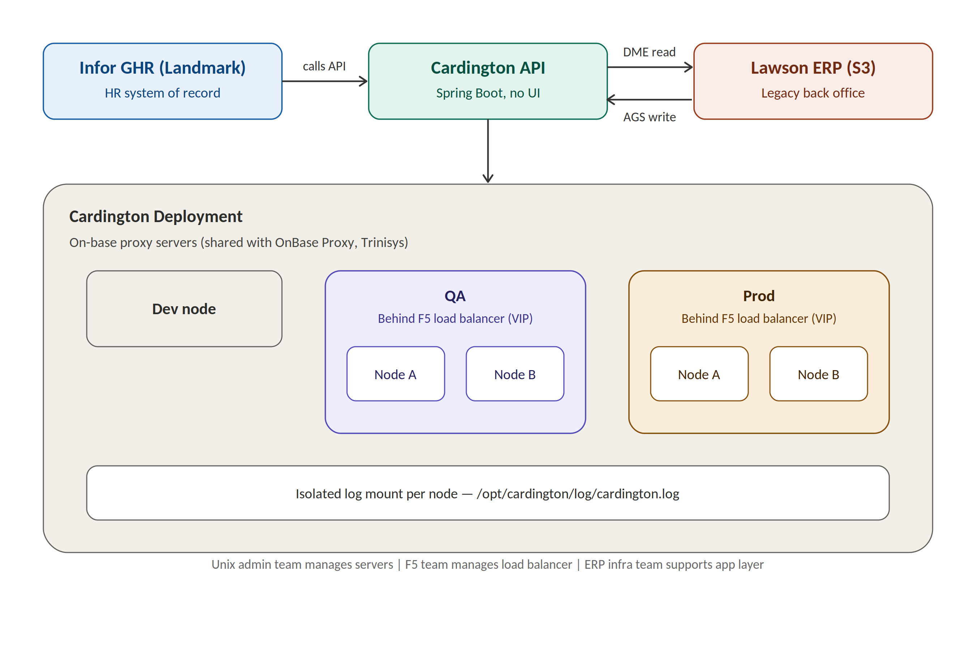
Figure 1: Cardington traffic flow and deployment architecture – GHR/Cardington/Lawson data flow (top) and the Dev/QA/Prod node layout behind the F5 VIP (bottom).

3.2 Infrastructure:
Cardington runs across five Unix nodes (Dev, QA Node A/B, Prod Node A/B). Production and QA nodes sit behind an F5 load balancer with a configured VIP. The Unix admin team manages the servers, the F5 team manages the load balancer, and the ERP infrastructure team supports the application layer.

Unix Servers | Name | Host | Port | IP
Cardington | Cardington Dev | xrdcldappobp01a.unix.medcity.net | 22 | 10.27.102.73
Cardington | Cardington QA Node A | xrdclqappobp01a.unix.medcity.net | 22 | 10.27.102.74
Cardington | Cardington QA Node B | xrdclqappobp01b.unix.medcity.net | 22 | 10.27.102.75
Cardington | Cardington Prod Node A | xrdclpappobp01a.unix.medcity.net | 22 | 10.27.82.103
Cardington | Cardington Prod Node B | xrdclpappobp01b.unix.medcity.net | 22 | 10.27.82.104

- cardington user profile and related passwords are configured in /home/cardington/.bash_profile.
- OnBase-related passwords/configuration are maintained separately in /home/obpsvc/.bash_profile.
- After any change to a bash profile, source it (run `source ~/.bash_profile` from the home directory) and restart the app for the change to take effect.

3.3 Service Management:
Cardington runs as a systemd service (cardington.service) and is packaged as a Spring Boot executable JAR deployed to /opt/cardington.
Status / Restart Commands:
- Status: sudo /usr/bin/systemctl status cardington.service
- Stop: sudo /usr/bin/systemctl stop cardington.service
- Start: sudo /usr/bin/systemctl start cardington.service
Cardington exposes Spring Actuator endpoints for service metrics and dynamic logging management, without requiring an app restart:
- Actuator base: http://xrdcldappobp01a.unix.medcity.net:8082/cardington/actuator
- Loggers: http://xrdcldappobp01a.unix.medcity.net:8082/cardington/actuator/loggers
- Swagger UI (DEV): http://xrdcldappobp01a.unix.medcity.net:8082/cardington/swagger-ui.html

3.4 CI/CD & Deployment:
Cardington is deployed via GitHub Actions. The primary workflow is “Build and Deploy” (maven.yml). The following actions are also available, mirroring the same stop/start/status pattern without a code change:
- Restart Cardington – stop/start/status
- Stop Cardington – stop the app and show status (status will report failure once stopped)
- Start Cardington – start the app and show status
- Cardington Status – show current status (fails if the app is down)

GitHub Environment | Permitted Actions / Protections
DEV | Deploy or restart. No protections.
QA Node A / QA Node B | Deploy or restart. Requires approval.
QA Node A restart / QA Node B restart | Restart only. No protections.
Prod Node A / Prod Node B | Deploy or restart. Requires approval.
Prod Node A restart / Prod Node B restart | Restart only. No protections.

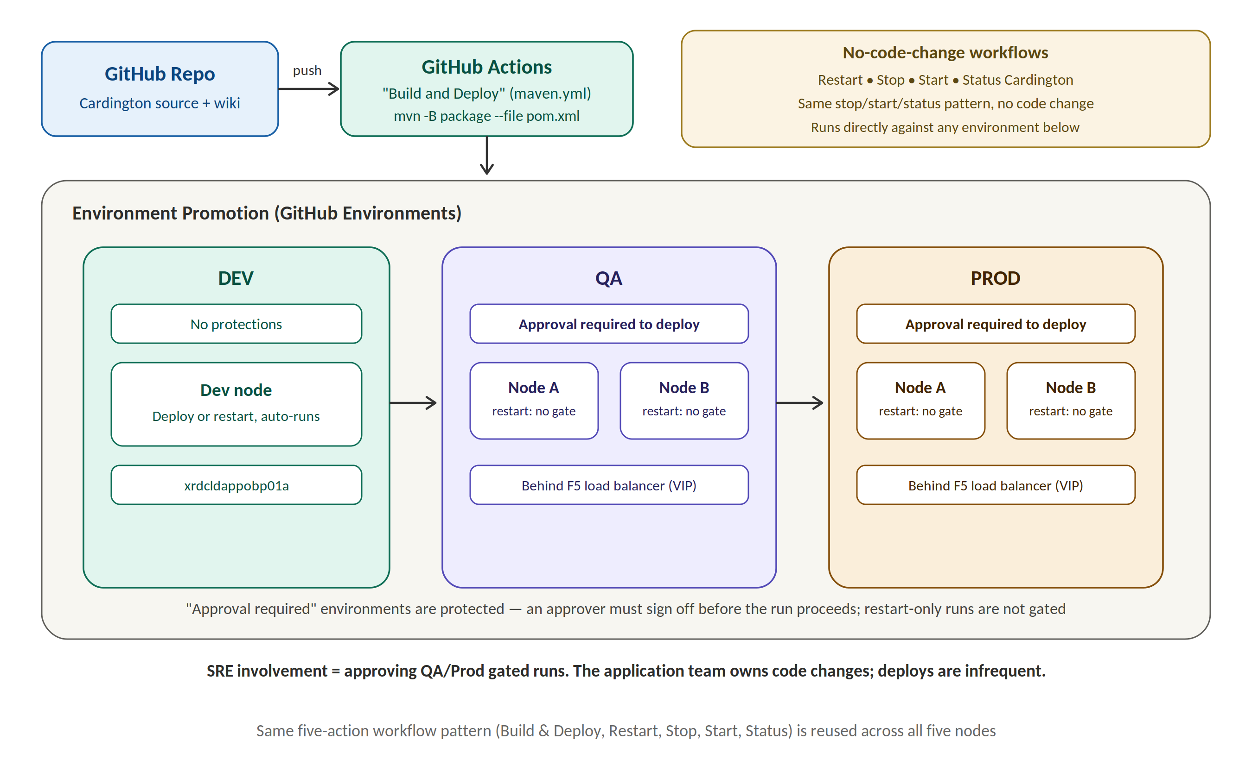
Figure 2: CI/CD pipeline – GitHub Actions builds from the repo and promotes through DEV (unprotected) → QA → Prod (both approval-gated); restart/stop/start/status workflows can target any node directly without a build.
SRE involvement in deployments is primarily limited to approving protected environment runs; deployments themselves are infrequent and the application requires minimal day-to-day intervention.

3.5 Logging & Diagnostics:
Log files are written to /opt/cardington/log/cardington.log. The log directory is isolated per application mount point, so log growth in Cardington does not impact other co-hosted services. The primary recurring operational issue is log files consuming disk space, which can cause the application to hang; clearing logs and restarting the service resolves this.
- Tail logs: tail -f /opt/cardington/log/cardington.log
Dynamically changing log levels (no restart required):
Verify current log level for a class/endpoint:
- curl "http://xrdcldappobp01a.unix.medcity.net:8082/cardington/actuator/loggers/com.hca.cardington.service.EmployeePTOService"
Update log level to DEBUG for a class/endpoint:
- curl -X POST "http://xrdcldappobp01a.unix.medcity.net:8082/cardington/actuator/loggers/com.hca.cardington.controllers.EmployeePTOController" -H "Content-Type: application/json" -d '{"configuredLevel":"DEBUG"}'
After changing a log level, re-invoke the relevant endpoint via Swagger and tail the log file to confirm the new verbosity, then re-verify the configured level via the GET request above.

4. Performance, Security & Scalability:
- Monitoring is performed via Dynatrace dashboards covering the Cardington server and Apache Tomcat.
- Because Cardington has no UI, synthetic monitoring is limited to server and port availability checks rather than UI-based synthetic transactions.
- Two nodes per environment (QA and Prod) sit behind an F5 load balancer for availability; current traffic levels do not require additional nodes.
- Access is secured via service accounts scoped per endpoint; only SSH (port 22) is required for server management, and firewall rules are already configured for API traffic – no additional ports need to be opened.

5. Source Code Walkthrough:
- Tech stack: Spring Boot 2.5.6, OpenJDK 1.8.
- Build: mvn -B package --file pom.xml (Note: the pom file has several JAXB dependencies commented out – uncomment if build exceptions occur.)
- Run locally (without conf files): java -jar -Dspring.profiles.active=DEV -Dsun.misc.URLClassPath.disableJarChecking=true -Dlogging.level.root=DEBUG ./target/Cardington-1.0.0-SNAPSHOT.jar
- Local log output is written to /opt/cardington/log.
- The codebase uses Lombok (for SLF4J logging, getters/setters) to reduce boilerplate – IDE plugin setup is required for Eclipse/IntelliJ.
- Source code and documentation (GitHub wiki) are maintained in the application's GitHub repository; SREs support runtime and infrastructure only, not application code changes.

6. Operations and Maintenance:
- Routine maintenance is centered on monitoring and clearing log directories before they fill available disk space.
- Restarting the service (via systemctl or the GitHub Actions “Restart Cardington” workflow) resolves most hang conditions caused by log growth.
- No P1/P2 incidents have occurred in recent years aside from log-space related issues.
- Cardington downtime is treated as Severity One / Priority One, since it directly impacts HR data accuracy displayed on the GHR portal – though it is considered less critical than an outage of Lawson itself.
- Postman collections are available (shared by the application team) for testing Cardington APIs end-to-end.
- Access management (GitHub repository permissions, distribution list membership) is coordinated with the application team during onboarding.

7. SRE Operational Activities (Daily / Weekly / Monthly)
Cardington is a low-touch application from an SRE standpoint – there is no UI, traffic is steady, and the application team owns code changes. The cadence below reflects the recurring checks the ERP SRE team performs to keep the integration between GHR and Lawson healthy.

7.1 Daily Activities:
Activity | Purpose / Notes
Dynatrace health check | Review Dynatrace dashboards for the Cardington server and Apache Tomcat (CPU, memory, process/port up-status) across Dev, QA, and Prod; Cardington has no UI, so this is the primary synthetic signal.
Disk space / log volume check | Check disk utilization on all five nodes, with particular attention to /opt/cardington/log/cardington.log – log growth filling the mount is the application's most common cause of a hang.
Alert triage | Scan for any new Dynatrace alerts or tickets tied to Cardington; since downtime is treated as Sev1/Pri1 (HR data accuracy on the GHR portal), triage promptly even though incidents are rare.
Service status spot-check | Where monitoring flags a node, confirm with sudo systemctl status cardington.service or the “Cardington Status” GitHub Action before escalating to the application team.

7.2 Weekly Activities:
Activity | Purpose / Notes
Log review | Tail /opt/cardington/log/cardington.log on each node and scan recent history for recurring errors/warnings, so issues are caught before they become disk-space or stability problems.
Pending deployment approvals | Review any outstanding GitHub Actions approval requests for the protected QA/Prod deploy or restart environments; confirm the change window with the application team (Venkat Deverakonda / Keith Boggs) before approving.
F5 / VIP health | Validate that F5 VIP health checks are passing for both the QA (Node A/B) and Prod (Node A/B) pairs.
Actuator reachability check | Confirm the Spring Actuator endpoints (/cardington/actuator, /cardington/actuator/loggers) respond on each environment as a lightweight, UI-independent synthetic check.

7.3 Monthly Activities:
Activity | Purpose / Notes
Proactive log housekeeping | Clear or archive aged log files on each node ahead of the disk threshold, in line with the application team's retention guidance, rather than waiting for a hang to force a reactive cleanup.
Access review | Reconcile GitHub repository permissions and distribution list membership against current SRE/application team rosters; flag stale access for removal with Daniel Joseph.
Server inventory validation | Re-validate hostnames, ports, and IPs for all five nodes against Section 3.2 of this SOP and correct any drift.
End-to-end workflow dry run | Exercise the Restart / Stop / Start / Status GitHub Actions against DEV to confirm the workflows still run cleanly, since production deployments themselves are infrequent.
Incident & SOP review | Check in with application team POCs on any P1/P2 events in the period and capture lessons learned or SOP updates; historically the only recurring issue has been log-space related.

These activities are in addition to ad-hoc support: approving protected GitHub Actions runs when the application team requests a deploy/restart, and responding to Sev1/Pri1 pages if Cardington goes down.

8. Key POCs
Application Team / Architecture Knowledge:
- Venkat Deverakonda – Cardington architecture, data flow, and deployment process
- Keith Boggs – Deployment environments, monitoring setup, operational concerns
- Daniel Joseph – Access management (GitHub, distribution lists)

ERP SRE Team:
- Yashraj Singh
- Shivakarthik Kumar

